
TESTFRAME ENGINE

VERSION 6.0
BUILD 58

INSTALLATION GUIDE

TestFrame Engine Installation Guide

Copyright © 1999–2007 LogicaCMG Nederland B.V.

All rights reserved. No part of this publication may be reproduced, or stored in a retrieval system, or transmitted, in any form, or by any other means, electronic, mechanical, photocopying, recording, or otherwise, without the prior consent of the copyright holder.

TestFrame is a trademark of LogicaCMG Nederland B.V.

This document also contains registered trademarks and trademarks which are owned by their respective companies or organizations. LogicaCMG disclaims any responsibility for specifying which marks are owned by which companies or organizations.

While every precaution has been taken in the preparation of this document, LogicaCMG assumes no responsibility for errors or omissions, or for damages resulting from the use of the information contained herein.

If you have any comments or suggestions regarding this document, please send them via e-mail to engine5@logicacmg.nl

For more information on LogicaCMG and TestFrame visit:
http://www.logicacmg.com
http://www.testframe.com

For more information on the TestFrame Engine write to:
engine5@logicacmg.nl

LogicaCMG Pubblic sector
Public Sector Technical Competence (PSTC)
P.O. Box 3190
2280 GD Rijswijk
The Netherlands
Telephone: +31 (0)70 375 6000
Telefax: +31 (0)70 375 6710
TABLE OF CONTENT

WELCOME TO THE TESTFRAME ENGINE 5
1 Installing the TestFrame Engine 6
2 Root directory structure 10
2.1 The Bin directory 11
2.2 The Cluster directory 12
2.3 The Doc directory 13
2.4 The Include directory 14
2.5 The Keep directory 15
2.6 The Lib directory 16
2.7 The Log Directory 17
2.8 The Report Directory 18
2.9 The Scripts directory 19
2.10 The Snap directory 20
2.11 The Template Directory 21
2.12 The license file 21
2.13 The ini file 22
3 Running the installation example 23
3.1 Running the example using C++ 23
3.2 Running the example using Java 24
3.3 Running the example using QARun 25
3.4 Running the example using Rational Robot 26
3.5 Running the example using Visual Basic 27
3.6 Running the example using WinRunner 28
3.7 Results of the installation example 29

WELCOME TO THE TESTFRAME ENGINE

Welcome to the TestFrame Engine, LogicaCMG’s tool for processing automated software tests designed using the TestFrame methodology. The Engine is the heart of TestFrame’s automated test environments, linking together test specifications, test software, and test results.

Using this guide

This guide describes how to install the TestFrame Engine.

The first chapter describes the steps to take during installation.

The second chapter gives an overview of the directory structure created during installation, and descriptions of the files placed herein.

The third chapter describes how to run the installation example in each of the supported environments.

Installing the TestFrame Engine
The TestFrame Engine must be installed by running the program TFEngineSetup.exe from the distributed installation files. Before starting this executable, please note the following.

- For installation on Windows 2000, XP and Vista systems, administrator rights are needed.

- Uninstall from your machine any previously installed version of ConTest Engine 5.5 or TestFrame Engine 5.0 before starting the setup executable.

When run, TFEngineSetup.exe starts the the installation procedure:

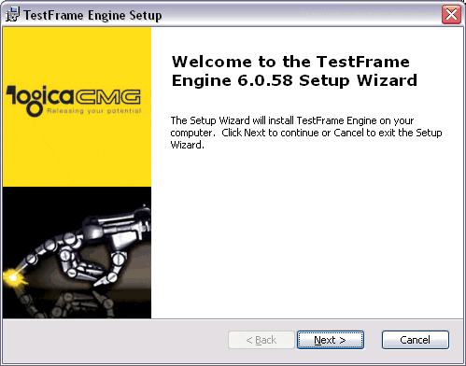

Before you start the installation you have to accept the license agreement (this is also found after installation as EULA.txt in the root directory where TestFrame Engine is installed):

Next you are asked where TestFrame Engine should be installed. The default destination directory is C:\TestFrame. You can browse to change the location of the destination directory:
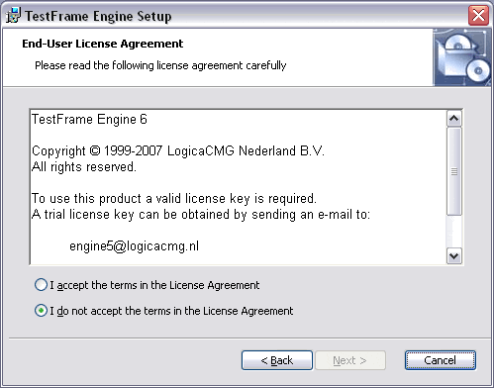

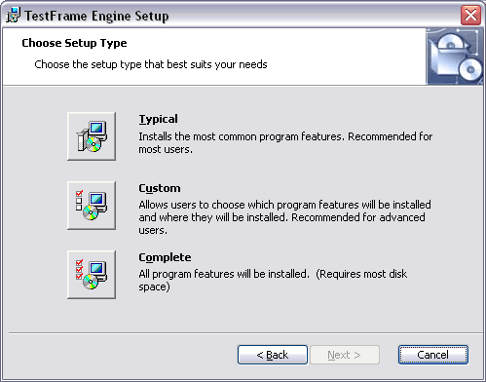
Here you have the choice to select which wrappers and example scripts to install. The TestFrame Engine currently supports WinRunner, QARun, Rational Robot, Java, C++, and Visual Basic example scripts. As of this version the TestFrame Engine installs all scripts as standard.
When you are satisfied with the settings you have made you can start the actual installation:

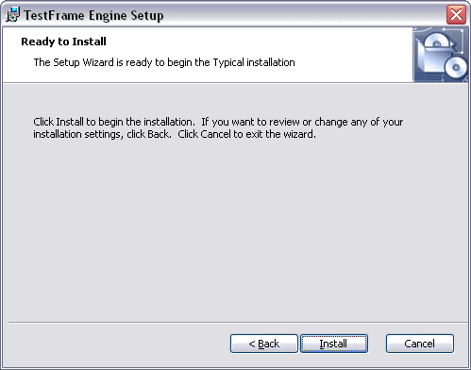

During installation the TestFrame Engine will be installed to the choosen destination (this directory structure will be later discussed in chapter 2). The newly created bin directory is added to the environment PATH variable.

When the installation has finished you can view the readme file which contains the latest information on this release of the TestFrame Engine:

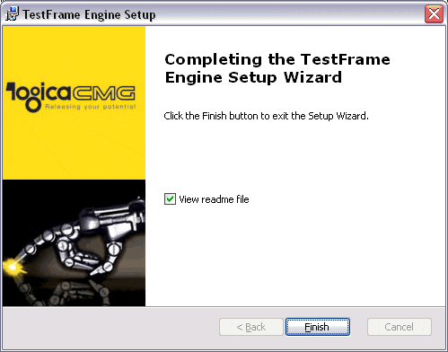

=============================================================================
Note that if you place the TestFrame Engine or any of the files described in this guide on your system without running this installation procedure, their proper functionalities are not guaranteed.
=============================================================================

Root directory structure
The root directory of TestFrame Engine is found at the location specified during the installation procedure. In this chapter the TestFrame directory structure will be explained. In the illustrations the root directory is C:\TestFrame, the actual directory can be different.

This directory structure is as follows:

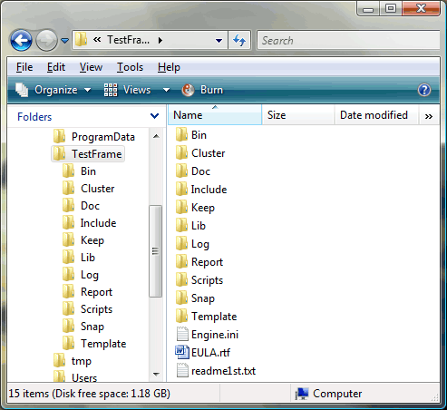

In subsequent paragraphs each subdirectory is explained in more detail.

The root directory contains several subdirectories and three files:
- engine.ini. This file contains the settings for the TestFrame Engine.
- EULA.txt. The license agreement file.
- readme1st.txt which contains installation instructions and the latest information on this release of TestFrame Engine (changes and bug fixes).

In order to work with TestFrame Engine you will need a valid license. The file “license.key”, has to be installed separately. See for more information paragraph 2.12.

The Bin directory
The Bin directory contains the dll’s and executables needed by the Engine. The content of the Bin directory should look like this:

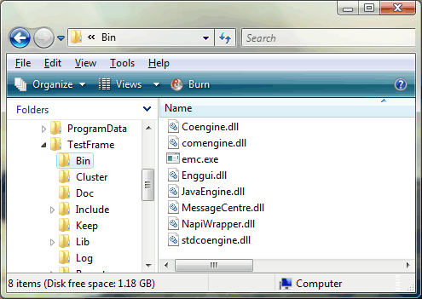

and contains the following files:

- Coengine.dll, which contains all the Engine functionality.
- Comengine.dll, COM wrapper (used for rational robot).
- emc.exe, the Engine Message Centre.
- Enggui.dll, TestFrame Engine’s graphical user interface.
- JavaEngine.dll, Java wrapper to access the TestFrame Engine.
- MessageCentre.dll, contains the functionality of the Engine Message Centre.
- NapiWrapper.dll, provides access to NAPI components.
- stdcoengine.dll, provides Visual Basic program access to the TestFrame Engine.

The Cluster directory
The Cluster directory contains Cluster files. The content of the Cluster directory should look like this:

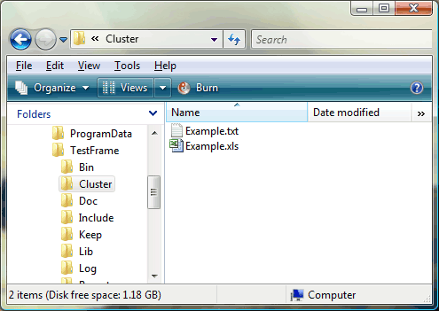

and contains the following files:

- Example.txt, the tab delimited cluster file needed for the examples.
- Example.xls, a Microsoft® Excel workbook version of this cluster.

The Doc directory
The Doc directory contains Documentation files. The content of the Doc directory should look like this:

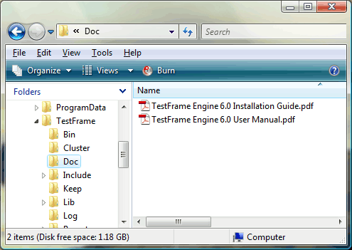

and contains the following files:

- TestFrame Engine 6.0 InstallationGuide.pdf, a copy of this document.
- TestFrame Engine 6.0 UserManual.pdf, the user’s guide for TestFrame Engine.

The Include directory
The Include directory is needed for the C++ scripts. Any necessary include files are placed here. The content of the Include directory should look like this:

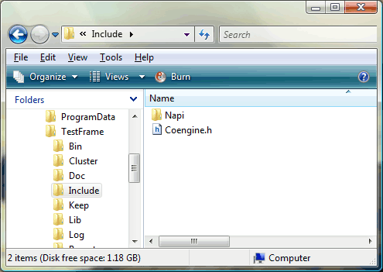

and contains the following files:

- Coengine.h, the header file of the Coengine.cpp source file.
- Napi.h and NapiWrapper.h, in the subdirectory Napi.

The Keep directory
The Keep directory is contains Keep files. The content of the Keep directory should look like this:

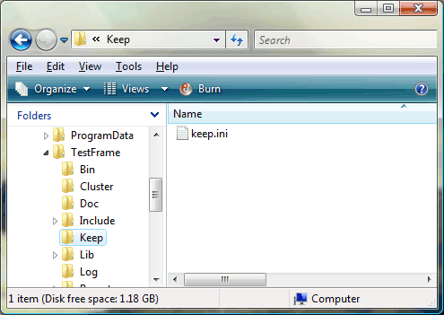

and contains the following files:

- Keep.ini, an empty keep file.

The Lib directory
The Lib directory is needed for the C++ scripts. The Lib directory contains Library files. The content of the Lib directory should look like this:

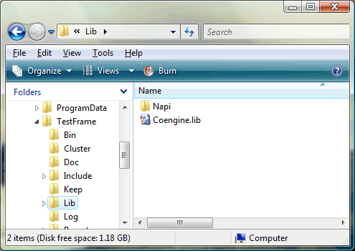

and contains the following files:

- Coengine.lib, the coengine library file (Release build only).
- Napiwrapper.lib and Navigation.lib (Release build only), in the subdirectory Napi.

The Log Directory
The Log directory contains TestFrame Engine log files. It is recommended to clean this directory by removing no longer needed files. The content of the Log directory should look like this:

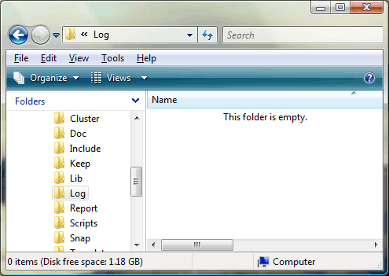

Initially this directory is empty.

The Report Directory
The Report directory contains test reports. The content of the Report directory should look like this:

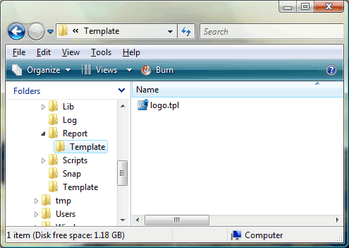

and contains the following files:

- logo.tpl, a subdirectory Template with the LogicaCMG logo (in RTF code) which is used in the test reports. It is possible to replace this logo with another.

The Scripts directory

The Scripts directory contains script files for different test environments/tools. The content of the Scripts directory should look like this:

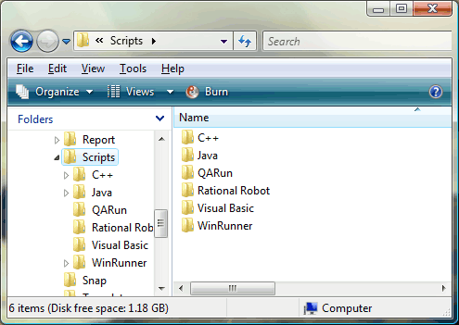

and contains the following subdirectories:

- C++
- Java
- Rational Robot
- QARun
- Visual Basic
- WinRunner

See chapter 3 for a more detailed explanation of each script subdirectory.

The Snap directory
The Snap directory contains snap files. The content of the Snap directory should look like this:

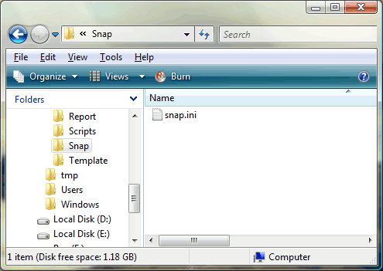

and contains the following files:

- snap.ini, an empty snap file.

The Template Directory
The Template directory contains TestFrame Engine cluster templates. The content of the Template directory should look like this:

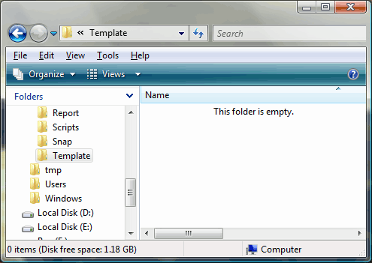

Initially this directory is empty.

The license file
To be able to use the TestFrame Engine a valid license is needed. This license file license.key must be placed in the directory specified in the section [LICENSE] of the engine.ini file. The license file is not part of the installation of the TestFrame Engine but can be obtained by sending a request to engine5@logicacmg.nl.

If the TestFrame Engine can not find a file named license.key that contains a valid encoded license key it will not run, and an error message will be written to a file named error.log which is placed in the working directory.
Note that when using a test tool, this directory probably is the test tool’s directory.

(Tip: use Find Files in the Start Menu to find error.log.)

The ini file
The file engine.ini in the root directory contains the settings for the TestFrame Engine.
Initially the root directory C:\TestFrame is used in this ini file. If you installed TestFrame Engine in another directory you should adjust engine.ini accordingly.

See the TestFrame Engine 6.0 User Manual for a detailed description of the settings in engine.ini.
The content of engine.ini should look like this:

[CLUSTER]
FileName=Example.txt
Path=C:\TestFrame\Cluster\

[GUI]
Detail=Yes
LaunchGUI=Yes
OnTop=No
Port=4000

[KEEP]
FileName=keep.ini
Path=C:\TestFrame\Keep\

[LICENSE]
Company=LogicaCMG
Name=TestFrame Engine
Path=C:\TestFrame\
SerialNumber=550-000001-0-01

[LOG]
Path=C:\TestFrame\Log\

[MASTERSLAVE]
Mode=Standalone
Port=4100

[REPORT]
Arguments=Yes
FileName=ExampleReport.rtf
Overwrite=Yes
Path=C:\TestFrame\Report\
TemplatePath=C:\TestFrame\Report\Template\

[SNAP]
FileName=snap.ini
Path=C:\TestFrame\Snap\

[SYSTEM]
AnythingPrefix=&Anything
ContText=&Cont
TimePrefix=&Time()
DatePrefix=&Date()
EmptyPrefix=&Empty
EngineBuild=1
EngineVersion=6.0
ExpressionPrefix=&
KeepPrefix=&Keep()
Language=GB
NotEmptyPrefix=&NotEmpty
Precision=6g
RedundantEscapeChars=
SnapPrefix=&Snap()
SpacesPrefix=&Spaces()
WaitForGUI=Yes

[TEMPLATE]
Path=C:\TestFrame\Template\

Running the installation example
A running example of TestFrame Engine is supplied with the installation. The example can run in all six before mentioned environments. The example cluster Example.txt is placed in the Cluster directory – see also paragraph 2.2.
The following paragraphs describe how to run this cluster in each of the supported environments; the last paragraph discusses the example’s results.

Running the example using C++
The Scripts\C++ directory contains the files needed for the C++ example. The content of the Scripts\C++ directory should look like this:

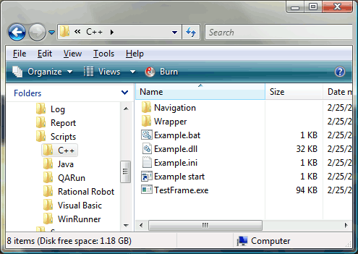

To run this example, you simply start example.bat. This batch file runs the application TestFrame.exe with the settings supplied in example.ini.

You can create your own TestFrame.exe from the files in the Wrapper subdirectory. A Microsoft Visual C++ project file (example wrapper.dsp for Visual C++ 6.0 and example wrapper.vcproj for Visual C++ .NET) is supplied for this purpose.
You also need to compile a dll, the navigation library, containing the implementation of the action words used in the example. The files for this project are located in the Navigation subdirectory. You will find there also the necessary project files (example dll.dsp and example dll.vcproj).

Both the executable (TestFrame.exe) and the navigation library (Example.dll) should be copied to the Scripts\C++ directory. If you want to keep the ones provided with the installation you should make a copy of them.

The C++ example needs the path to an ini file as a command line parameter. This file tells the C++ wrapper which engine configuration file, which cluster, and which report file to use during the test run. It also tells the wrapper which navigation libraries should be loaded. Note this file is another file besides engine.ini.
This ini file—Example.ini—has only one section—[TestFrame]—with the four following entries: Cluster, Report, IniFile and Library. Each entry should contain a path. The Library entry can contain more than one path, separated by semicolons. This makes it possible to use more than one navigation library in a single test run.

Running the example using Java
The Scripts\Java directory contains the files needed for the Java example. The content of the Scripts\C++ directory should look like this:

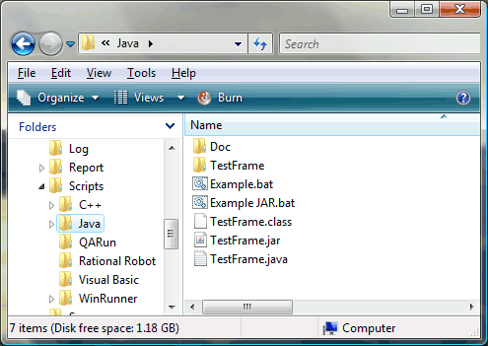

To run this example, you simply start example.bat. This batch file runs the Java application wrapper.

You can create your own Java wrapper. Therefore TestFrame.java needs to be compiled to a class file. For that you need the Java Development Kit (JDK) 1.5 (or higher) (for more information see www.javasoft.com) . Open a Command Window, go to the Scripts\Java directory and type:

C:\TestFrame\Scripts\Java> javac TestFrame.java

This will produce the file TestFrame.class. This file is also added to this directory during installation.
To run the example you need to provide three parameters: the name of the ini file, the cluster name, and the report name respectively. To run the example enter the following line on the command line:

C:\TestFrame\Scripts\Java> java TestFrame C:\TestFrame\engine.ini
C:\TestFrame\Cluster\Example.txt c:\TestFrame\Report\ExampleReport.rtf

Running the example using QARun
The Scripts\QARun directory contains the scripts which were developed in QARun for Win32 Version 4.7.0 (Build 301). The content of the Scripts\QARun directory should look like this:

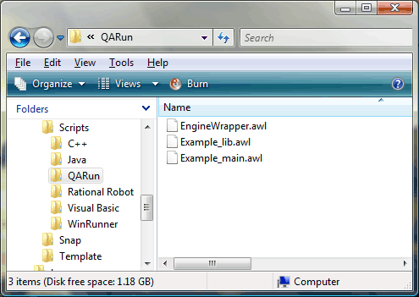

QARun uses a database in which the test scripts are stored. Since QARun databases are dependent on the version used, no database is installed, but only the awl files.

To run this example, start QARun, open a database and import the three awl files from the directory Scripts\QARun. Open the script Example_main and run it—by using Run Script.

Running the example using Rational Robot
The Scripts\Rational Robot directory contains the scripts which were developed in Rational Robot Version 7.5.0.1081. The content of the Scripts\Rational Robot directory should look like this:

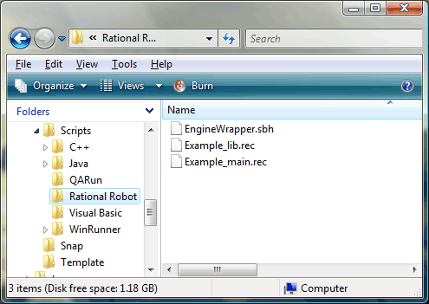

Rational Robot uses a database in which the test scripts are stored. With this example, however, no database is installed, but only the rec files and the sbh file.

To run this example, start Rational Robot, login on a repository, and place in the project as GUI scripts the two rec files, and as Project Header File the sbh file from the directory Rational Robot. Select the option Playback Script and choose the script Example_main.

Running the example using Visual Basic
The Scripts\Visual Basic directory contains the files needed for the Visual Basic example. The content of the Scripts\Visual Basic directory should look like this:

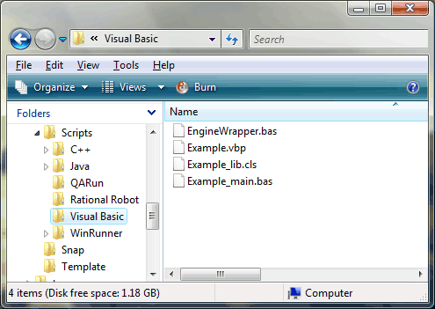

To run the Visual Basic example, make an executable named Example.exe. A Microsoft Visual Basic 6.0 project file (Example.vbp) is supplied for this purpose. The executable (Example.exe) should be copied to the Scripts\Visual Basic directory.

Running the example using WinRunner
The Scripts\WinRunner directory contains the scripts which were developed in WinRunner. The content of the Scripts\WinRunner directory should look like this:

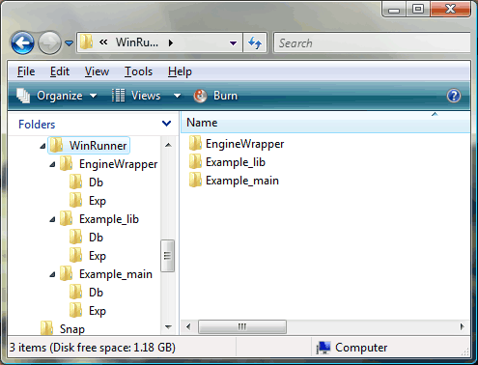

To run this example, start WinRunner, open the script Example_main and run it—preferably using the option “Run Minimized From top”.

Results of the installation example
In the cluster Example.txt some functionality of the TestFrame Engine is demonstrated.

After the example test has been run, a test report which contains the results of the test is stored in the Report directory as ExampleReport.rtf:

